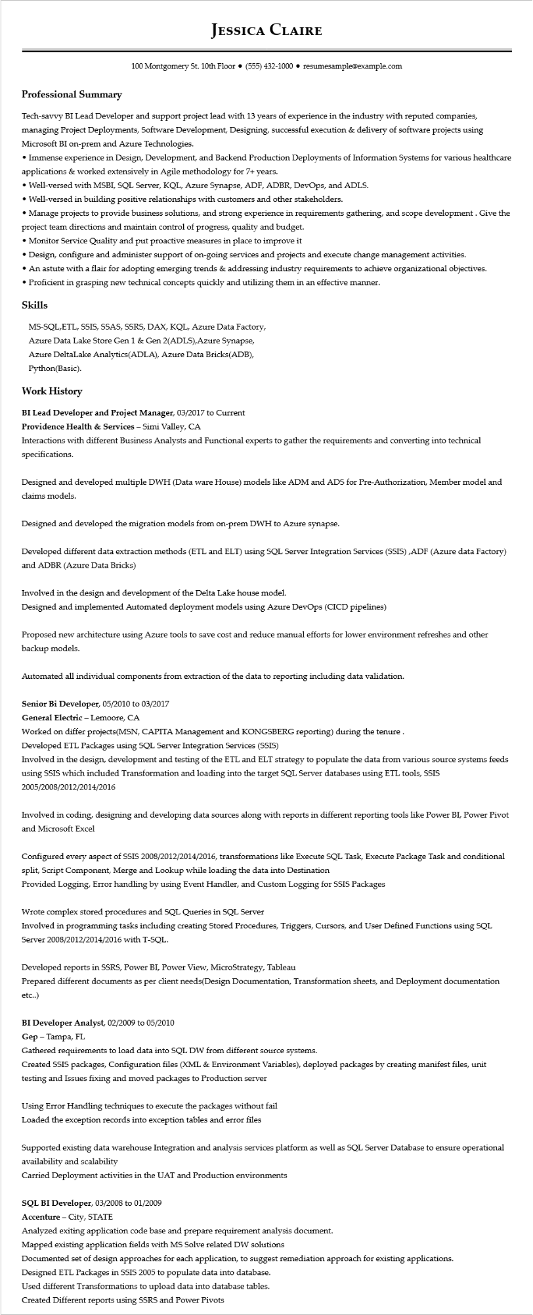
Professional Summary
JESSICA CLAIRE
100 Montgomery St. 10th Floor⚫ (555) 432-1000⚫ resumesample@example.com
Tech-savvy BI Lead Developer and support project lead with 13 years of experience in the industry with reputed companies, managing Project Deployments, Software Development, Designing, successful execution & delivery of software projects using Microsoft BI on-prem and Azure Technologies.
• Immense experience in Design, Development, and Backend Production Deployments of Information Systems for various healthcare applications & worked extensively in Agile methodology for 7+ years.
• Well-versed with MSBI, SQL Server, KQL, Azure Synapse, ADF, ADBR, DevOps, and ADLS.
• Well-versed in building positive relationships with customers and other stakeholders.
• Manage projects to provide business solutions, and strong experience in requirements gathering, and scope development. Give the project team directions and maintain control of progress, quality and budget.
• Monitor Service Quality and put proactive measures in place to improve it
• Design, configure and administer support of on-going services and projects and execute change management activities.
• An astute with a flair for adopting emerging trends & addressing industry requirements to achieve organizational objectives.
• Proficient in grasping new technical concepts quickly and utilizing them in an effective manner.
Skills
MS-SQL, ETL, SSIS, SSAS, SSRS, DAX, KQL, Azure Data Factory, Azure Data Lake Store Gen 1 & Gen 2(ADLS), Azure Synapse,
Azure DeltaLake Analytics(ADLA), Azure Data Bricks(ADB), Python(Basic).
Work History
BI Lead Developer and Project Manager, 03/2017 to Current
Providence Health & Services - Simi Valley, CA
Interactions with different Business Analysts and Functional experts to gather the requirements and converting into technical specifications.
Designed and developed multiple DWH (Data ware House) models like ADM and ADS for Pre-Authorization, Member model and claims models.
Designed and developed the migration models from on-prem DWH to Azure synapse.
Developed different data extraction methods (ETL and ELT) using SQL Server Integration Services (SSIS),ADF (Azure data Factory) and ADBR (Azure Data Bricks)
Involved in the design and development of the Delta Lake house model.
Designed and implemented Automated deployment models using Azure DevOps (CICD pipelines)
Proposed new architecture using Azure tools to save cost and reduce manual efforts for lower environment refreshes and other backup models.
Automated all individual components from extraction of the data to reporting including data validation.
Senior Bi Developer, 05/2010 to 03/2017
General Electric - Lemoore, CA
Worked on differ projects(MSN, CAPITA Management and KONGSBERG reporting) during the tenure. Developed ETL Packages using SQL Server Integration Services (SSIS)
Involved in the design, development and testing of the ETL and ELT strategy to populate the data from various source systems feeds using SSIS which included Transformation and loading into the target SQL Server databases using ETL tools, SSIS 2005/2008/2012/2014/2016
Involved in coding, designing and developing data sources along with reports in different reporting tools like Power BI, Power Pivot and Microsoft Excel
Configured every aspect of SSIS 2008/2012/2014/2016, transformations like Execute SQL Task, Execute Package Task and conditional split, Script Component, Merge and Lookup while loading the data into Destination
Provided Logging, Error handling by using Event Handler, and Custom Logging for SSIS Packages
Wrote complex stored procedures and SQL Queries in SQL Server
Involved in programming tasks including creating Stored Procedures, Triggers, Cursors, and User Defined Functions using SQL Server 2008/2012/2014/2016 with T-SQL.
Developed reports in SSRS, Power BI, Power View, MicroStrategy, Tableau
Prepared different documents as per client needs(Design Documentation, Transformation sheets, and Deployment documentation etc..)
BI Developer Analyst, 02/2009 to 05/2010
Gep - Tampa, FL
Gathered requirements to load data into SQL DW from different source systems.
Created SSIS packages, Configuration files (XML & Environment Variables), deployed packages by creating manifest files, unit
testing and Issues fixing and moved packages to Production server
Using Error Handling techniques to execute the packages without fail
Loaded the exception records into exception tables and error files
Supported existing data warehouse Integration and analysis services platform as well as SQL Server Database to ensure operational availability and scalability
Carried Deployment activities in the UAT and Production environments
SQL BI Developer, 03/2008 to 01/2009
Accenture - City, STATE
Analyzed exiting application code base and prepare requirement analysis document.
Mapped existing application fields with MS Solve related DW solutions
Documented set of design approaches for each application, to suggest remediation approach for existing applications.
Designed ETL Packages in SSIS 2005 to populate data into database.
Used different Transformations to upload data into database tables.
Created Different reports using SSRS and Power Pivots

